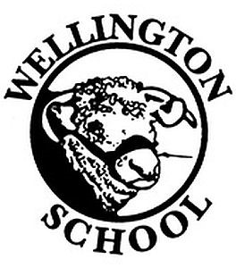
Owl Class Autumn Homework
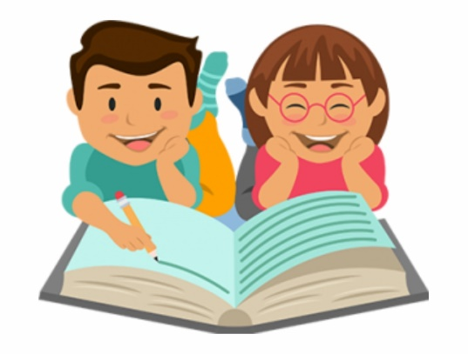
Maths
Learn your multiplication tables up to 12 x 12.
Try and teach someone at home some of the calculations you have using in class.
English
Read at least 3 times a week. Parents must sign reading record books 3 times a week, to acknowledge you have read.
Try to learn as many of the year 5/6 spellings and continue with your weekly spellings.

Topic: Ancient Greece
For this half-term, we are asking that the children research our Ancient Greek topic. Some ideas could be:
- Make a Spartan helmet or design a shield
- Make a model of an Ancient Greek building or statue.
- Research the very first Olympic Games and present in a way of your choosing.
- Cook a meal inspired by Ancient Greek cooking/diets.
- Create a fact file or poster about your favourite Greek God(s) or myths.
- Find out about what life was like for children in Ancient Greece.
- Create your own Greek vase showing a famous myth.
- Research Alexander the Great.
- Create a drawing, painting or animation about an aspect of Greek life.
- Turn a myth into a cartoon, for example, Theseus and the Minotaur. Use lots of speech bubbles.
- Famous Greeks: The Greeks were famous for their clever thinking and we still remember and use some of their ideas today. Examples are Pythagoras, Aristotle, Hipocrates. Research a famous ancient Greek and present a 2-minute talk to share with your class about what you have learnt. You may use PowerPoint if you wish.
Please remember that these are ideas - you can respond with other homework based on our Ancient Greek topic.
Due in date: Week beginning 21st October 2024
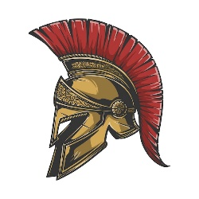
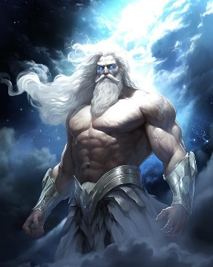

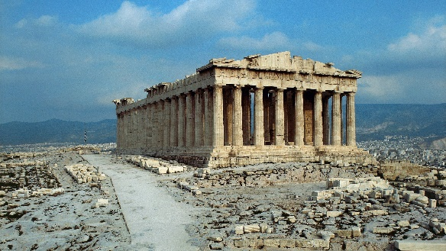

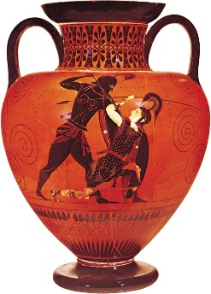

Please only

