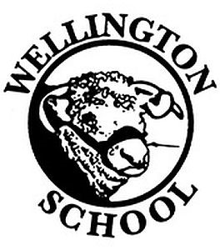
Owl Class Autumn Homework
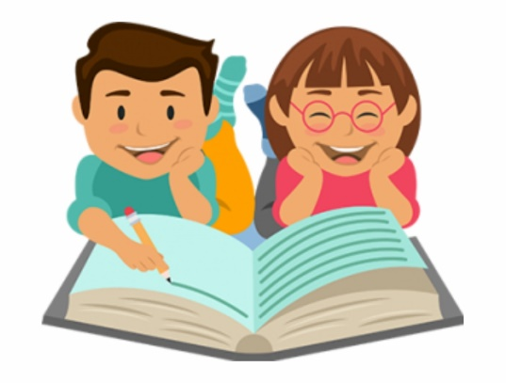
Maths
Learn your multiplication tables up to 12 x 12.
Try and teach someone at home some of the calculations you have been using in class.
English
Read at least 3 times a week. Parents must sign reading record books 3 times a week, to acknowledge you have read.
Try to learn as many of the year 5/6 spellings and continue with your weekly spellings.

Topic: Countries of the World
For this half-term, we are asking that the children research our World Countries topic.

- Design and create a 3D map
- Make a model of a famous landmark.
- Research animals that are native to a particular country (eg: lemurs, kangaroo etc…)
- Cook a meal inspired by a country’s cuisine – remember the photos on SeeSaw.
- Research and create a report about an environmental issue facing a particular country.
- Design a holiday brochure for a country of your choice
- Design a poster/PowerPoint of traditional clothing from a country of your choice
- Create, draw and colour a selection of international flags
- Create a PowerPoint or Fact file about any country of your choice. You could include information on culture,
religions, currency, languages, leaders, landmarks, rivers, mountains etc.…
Please remember that these are ideas - you can respond with other homework based on our geography topic.

Due in date: Week beginning 16th December 2024
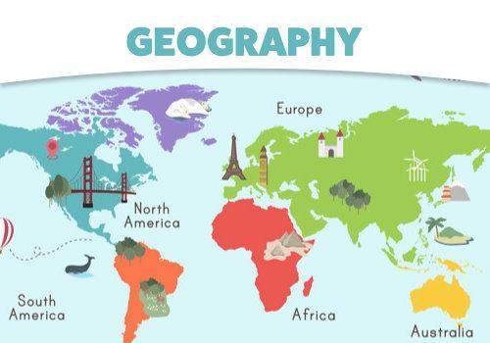

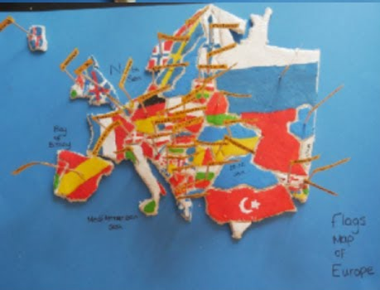

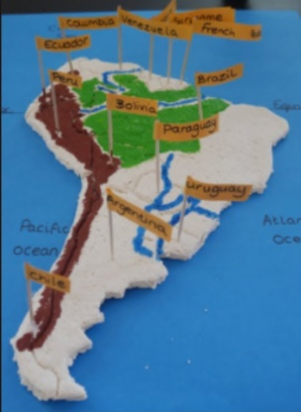

Please only

