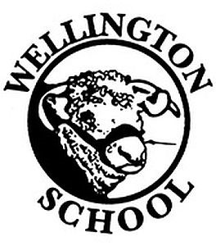
Owl Class Spring Homework

Maths
Learn your multiplication tables up to 12 x 12.
Try and teach someone at home some of the calculations you have using in class.
English
Read at least 3 times a week. Parents must sign reading record books 3 times a week, to acknowledge you have read.
Try to learn as many of the year 5/6 spellings and continue with your weekly spellings.

Topic: Ancient Maya
For this half-term, we are asking that the children research our Ancient Maya topic. Some ideas could be:

- Make a model of a Mayan pyramid(s)
- Make a Mayan head-dress for a King or Queen, using recycled materials
- Research the Mayan sport (Pok a Tok) and present your findings (a ball game where you cannot use hands or feet…hmmm?)
- Draw or build (DT) your own version of the Mayan calendar (see the picture)
- Cook a meal inspired by Mayan cooking/diets.
- Research the Mayan number system and report your findings to the class.
- The Maya loved chocolate!! Can you find out about how chocolate is made?
- Create a fact file or poster about your favourite Mayan God(s) or myths.
- Find out about what life was like for children.
- Create a drawing, painting or animation about an aspect of Mayan life.

Please remember that these are ideas - you can respond with other homework based on our Ancient Maya topic.
Due in date: Week beginning 7th April 2025
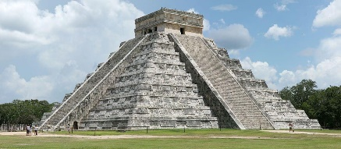
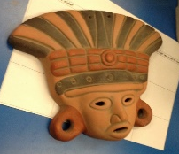

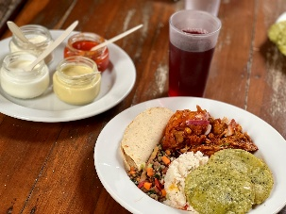
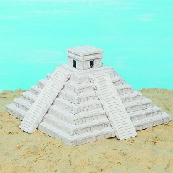
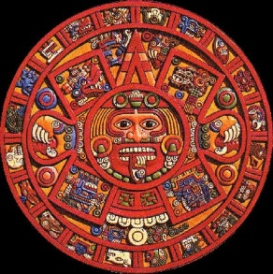

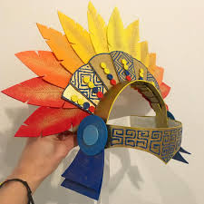
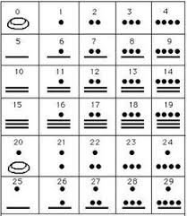

Please only

